Modular Building

6 Prefab Houses That Could Change Home Building

Affordable prices, cool design, easy delivery. What’s not to like?
By:
Nigel F. Maynard
Retrieved December 10, 2012 from http://www.builderonline.com/modular-building/6-prefab-houses-that-could-change-home-building.aspx

- 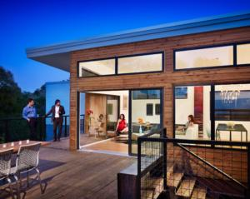

Remember when prefab housing was supposed to be the cost-reducing savior in a housing market where prices had ballooned way out of control? Sure you do. It wasn’t that long ago.
Well, you’d think that with prices falling as fast as a brick that prefab housing would be a non-factor, but just the opposite appears to be true. In fact, prefab may play an even bigger role in the housing industry from here on, architects and builders say.
“I think that it will be without question,” says Middleburg, Va.-based Russell Versaci (www.russellversaci.com), who believes consumers and builder/developers will drive this trend. “The consumer is looking for a straightforward alternative to a tract home, and the only efficient way for them to get it will be through modular building process.”
Versaci, who designs the Simple Cottages and Simple Farmhouse prefab housing lines for Haven Custom Homes (www.havenhomes.com) in Linthicum, Md., and also works with Connor Homes in Middlebury, Vt. (www.connorbuilding.com), believes consumers will be able to get such a house inexpensively through the modular process.
“This is what I’m driving for,” the architect continues. “Our small houses, for example, should be able to be completed in place for about $250,000 to $300,000. What we’re doing is trying to compete directly with the tract builder.”
The prefab/modular industry has been around for decades and has managed to do well for itself, but in recent years, the category has generated buzz with (some might say much-needed) edgy designs from hot-shot architects such as Michelle Kaufmann (www.mkd-arc.com), Marmol Radziner (www.marmolradzinerprefab.com), Resolution: 4 Architecture (re4a.com.), Geoffrey Warner (www.weehouse.com), and many others.
And now more architects and builders are jumping into the fray with a new set of prefab homes and prototypes to solve issues, turn heads, and, more importantly, fill a need. Take a look for yourself at what the future could look like.

Ma Modular
- 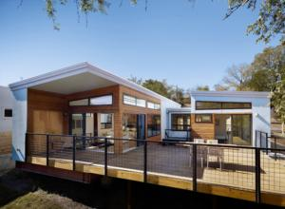

KRBD is an Austin, Texas-based design/build firm that specializes in affordable, modern custom homes and speculative multifamily developments. Now the company is making its work even more accessible with ma Modular. “With ma, we’re continuing the idea of building quality, modern spaces efficiently that was started with our design/build firm here in Austin,” says architect Chris Krager, KRDB’s principal and co-owner of ma Modular. “Ma enables us to expand our reach.”
Offered at a base price of $150 per square foot, ma is “the promise of prefab fulfilled,” the company says. It’s available in two module sizes—36 feet by 15 feet and 60 feet by 15 feet—and has three available floor plans, which make up the six building blocks of the system. The modules can be linked in an unlimited variety of ways, including one- and two-story configurations, allowing future homeowners to customize to their specific needs and site.
Like most modular houses, ma homes are delivered fully equipped with plumbing, electrical fixtures, and appliances and will require minimal site work. Each home features 2X6 exterior walls, metal roofs, R30 to R50 roof insulation, low-E insulated windows, bamboo floors, and solid surface countertops, among other amenities.
“The buildings are economically efficient and spatially superior, flexible to many contexts and clients,” says Krager. “We’re merging two worlds—taking advantage of what the industry is doing well and adding a clean, smart, modern design that is fun and accessible.” www.krdb.com.

Unity Collection
- 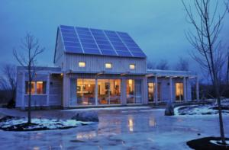

What if a prefab home could save you money every month or give you independence from the local utility? Prefab timberframe manufacturer Bensonwood Homes in Walpole, N.H., says it has come up a collection of homes that do just that. Unity Collection, the company says, is the first engineered net-zero homes capable of producing as much energy as they consume.
Designed for efficiency, the house gets its annual energy requirements from sunlight, wind, or geothermal. The key to this system is a highly efficient and tight building envelope. Walls are R-40, the roof is R-67, and the slab is rated at R-20. A heat recovery ventilator will bring in fresh air, triple-glazed windows will help conserve energy, and Energy Star appliances will save water and energy.
“A Bensonwood home is comparable in cost to high-quality construction going on in the area where the home is being built, if that high-quality conventional construction is built with the same durability and comparable insulation in our timber frame homes,” the company says. “However, because Bensonwood home designs and estimates are highly accurate, our clients enjoy the benefit of having predictable costs with very few surprises.” www.bensonwood.com/unity

Simple Cottage Sampler
- 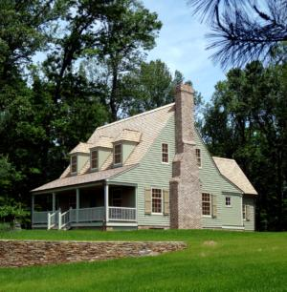

Builders—especially the big ones—and architects, says architect Russell Versaci, have done a disservice to the American home buyer. "I'm just horrified by the monoculture of home building in this country," he once told the McClatchy-Tribune. "Basically, it's like big-box shopping malls--no matter where you go, they're all the same."
The Middleburg, Va.-based Versaci specializes in high-end custom homes, but he's also on a quest to make traditional design (especially regionally appropriate vernacular work) more affordable. Using the successful Sears Home model, Versaci has formed a partnership with Haven Custom Homes in Linthicum to design kit houses that are affordable and better designed, he says. “I saw prefab as a solution for getting better design into the marketplace, a solution for the cost problem, and a way to diversify my practice.”
The recently introduced Simple Cottage Sampler is a new collection of small homes designed specifically for modular building. Ranging in size from 450 square feet to 900 square feet (they can be increased in size by adding modular units), the line features 10 authentic vernacular architectural styles such as Chesapeake Tidewater and Louisiana Creole and will possess architectural features usually found only in higher-end homes.
Houses will be delivered to the site 90% complete. www.havenhomes.com.

BrightBuilt Barn
- 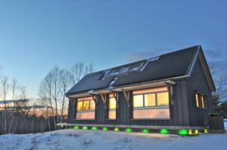
Credit: Photo by Naomi C.O. Beal

Credit: Photo by Naomi C.O. Beal
When Portland, Maine-based Kaplan Thompson Architects received a simple commission for an outbuilding, they had little idea that it would turn into a much more important endeavor. The client had a lofty goal to create a high-performance structure that also could serve as a demonstration project to help educate the industry about net-zero houses.
Collaborating with Walpole, N.H.-based prefab manufacturer Bensonwood Homes and a variety of green engineers, Kaplan Thompson came up with the BrightBuilt Barn, a 756-square-foot single-level outbuilding on the clients’ property in Rockport, Maine. The 90% prefabricated structure features a continuous R-40 shell and has 2x6 exterior walls, blown-in cellulose insulation, timber-frame structural insulated panels, and triple-glazed windows. Instead of a furnace, the barn has an air-to-air heat pump (which operates at temperatures as low as 0 degrees F), a 5-kilowatt photovoltaic system, solar hot water, and a heat recovery ventilator.
A real-time energy feedback system allows owners to see their current energy usage levels. LED lights installed around the base of and inside the structure are programmed to glow in three colors: green when the building is using less energy than is being produced, yellow when it’s borderline, and red when it exceeds net-zero goals.
The product line can be purchased at a base price of less than $200,000 (not including site and foundation work and other essentials). Several upgrade options also are available. www.brightbuiltbarn.com.

IKEA.SmartCarHouse
- 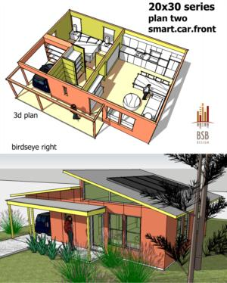

There is something that puzzles architect Ed Binkley about the current state of home building and buying. “We don’t buy cars by the pound, so why should we buy homes by the square footage?” says Binkley, an Oviedo, Fla.-based partner in the venerable architecture firm BSB Design. “[T]his is the underlying design statement in the development of the 600 sf Series homes.”
Because “we buy cars based on comfort, price, accessibility, features, uniqueness, and how well they address our needs, wants, and desires,” Binkley believes, we should use the same criteria for making our home buying decisions.
So Binkley began considering popular iconic symbols that extol these virtues and set out to come up with a housing prototype that incorporates them. Behold the IKEA.SmartCarHouse. The 600-square-foot home revolves around a design that meets all of the aforementioned criteria and does so in a way that is progressive, affordable, and available in a variety of architectural styles. Though small, the spaces allow for flexibility. A smaller version of the home, with the garage, contains a single bedroom and measures 528 square feet. The total construction cost, minus site, is estimated at $40 per square foot or $24,000 for the 600-square-foot model.
“The challenges are apparent; the need for (real) affordable housing is obvious,” Binkley says. “There are plenty of great examples of systems housing out there but most are still outside the price range of those in the most need. The intention of this concept is to bridge the gap between mass market housing and the very low-end housing that often does not address the style factor that many buyers desire.” www.bsbdesign.com.

HOM Escape in Style
- 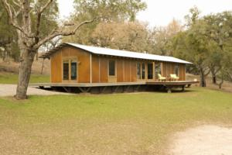

The architects at Los Angeles-based KAA Design Group thought long and hard about an efficient way to deliver a non-site-built house that was cool and easy to build. The fruits of their group-think yielded HOM Escape in Style, a line of modern manufactured houses and lifestyle products.
Against conventional wisdom, the firm used the 85-year-old mobile home industry for inspiration. The home is available in three models ranging in size from 1,000 to 3,600 square feet. Potential buyers may choose size customization and configuration, finishes, and furnishings and then link to a local dealer for installation.
The firm designed the home to be eco-friendly, so it features a long list of sustainable materials and environmentally sound construction techniques, such as FSC certified woods, organic linens, LED light bulbs, and recycled aluminum. And because it’s built in a factory setting the process minimizes construction material waste.
“Our mission is to create products that inspire people and seamlessly connect modern architecture and high design with eco-consciousness,” says HOM design team member and head of the KAA Brand Experience Studio, Melanie Robinson. “With HOM’s efficient yet graceful aesthetic, adventuresome families and forward-thinking individuals no longer have to forgo high design for sustainable living.”
The homes are delivered to the site 90% complete and have a starting price of $200 per square foot. The line also includes modular seating, dining tables, beds, lighting, textiles, and accessories. www.homlifestyle.com.

