Chapter 7 Review
Name:____________________
Period:_____________

Simplify each expression
1. (x²)(7x⁸) 1._________________

2. (5a⁷bc²)(-6a²bc⁵) 2.__________________

3. (-1.23)⁰ 3.__________________

4. x⁶y⁸/x² 4.__________________

5. (2a⁴b³/c⁶)⁰ 5.__________________

6. 2xy⁻⁷/ 8x 6.__________________

7. $\sqrt[3]{1000}$ 7.__________________

8. $\sqrt[5]{3125}$ 8.__________________
9. 1728^{1/3} 9.__________________

10. (16/81)^{1/2} 10._________________

11. 27^{2/3} 11._________________

12. 10,000^{3/4} 12._________________

13. 27^{5/3} 13._________________

14. (1/121)^{3/2} 14._________________

Solve each equation
15. 12^{x} = 1728 15._________________

16. 7^{x-1} = 2401 16._________________

17. 9^{x-3} = 729 17._________________

Express each number in scientific notation
18. 0.00021 18._________________

19. 58,000 19._________________

Express each number in standard form
20. 2.9 x 10⁻⁵ 20._________________

21. 9.1 x 10⁶ 21._________________

Evaluate each product or quotient. Express you answer in scientific notation
22. (2.5 x 10³)(3 x 10⁴) 22._________________

23. 8.8 x 10²/ 4 x 10⁻⁴ 23._________________

24. The average distance from Mercury to the Sun is 35,980,000 miles. Express this distance in scientific notation.

24._________________

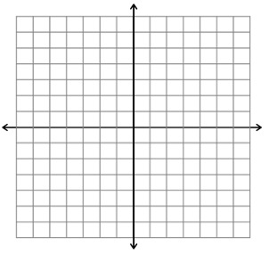
Graph each function. Find the y-intercept and state the domain and range
25. y = 2(5)^{x}

y- intercept:_______________
domain:__________________
Range:___________________

26. y = -3(11)^{x}

y- intercept:______________
Domain:_________________
Range:__________________

27. y = 3x + 2

y- intercept:____________
Domain:_______________
Range:________________
BONUS
Find the slope of the line that passes through each pair of points, then write an equation in point-slope form, slope-intercept form, and standard form.
- (0, -2) and (-5, -4)
Slope = ____________________________
Point - slope = _______________________
Slope-Intercept =______________________
Standard = ____________________________

Solve each system by graphing.
- y = 4x + 7
y = -3x

Solve using substitution.
- –3x + y = -2
y = x + 6

Solve by elimination.
- 2x + 4y = -4
2x + y = 8

Graph each linear inequality.
- y < 2x – 5

