Consumers can order all three of their credit reports and scores from www.annualcreditreport.com. (Trans Union, Equifax, & Experian) You are entitled to one free credit report every year from each of the three credit reporting agencies. You'll have to pay extra to get your credit scores, but it's worth it, says John Ulzheimer, president of educational services for Credit.com, a website focusing on consumer credit. "You've got to know what your scores are before you can start doing anything to change them."
Which is why Ulzheimer recommends ordering a credit score from each of the three credit bureaus: TransUnion, Equifax and Experian.
You can buy your credit scores when you request your free credit reports. The cost for each score ranges from $5.95 to $7.95.
Because some lenders don't report information about borrowers to all three credit bureaus, your credit scores will vary. For that reason, you should get all three scores before applying for a mortgage, Ulzheimer says. Mortgage lenders, he says, usually base their decisions on your middle score.
Reprinted with permission. All rights reserved.
What counts toward your FICO credit score
Payment history 35%
Amount you owe 30%
New credit 10%
Types of credit you’re using 10%

Length of credit history 15%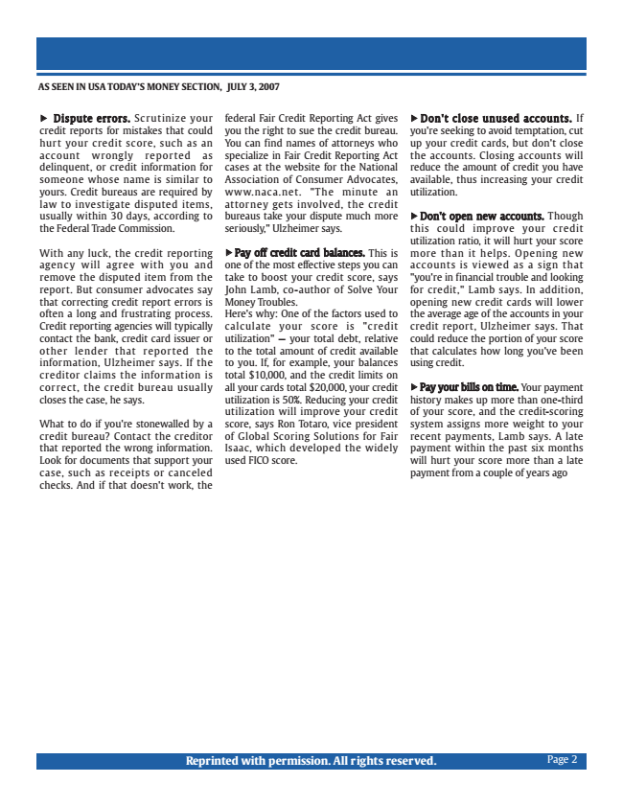

AS SEEN IN USA TODAY’S MONEY SECTION, JULY 3, 2015Reprinted with permission. All rights reserved.
Marketing - 25 minutes – Read the article and discuss questions

Read “A strong credit score can help you score a lower rate on a mortgage.” When you are finished reading, answer the following questions.
• What is a credit score?

• How is a credit score calculated? (Hint: look at the chart accompanying the article for help.)

• What are the names of the three credit bureaus that calculate your credit score?

• Why is a good or high credit score important?

• Look at the chart found in the article. How much would you pay for a $300,000 home over 30 years if you had a credit score of 615? How much would you pay for the same home if your credit score was 768? How much would you save over 30 years with the higher credit score?

• As you begin to use credit cards, what are some ways you can ensure your credit score stays high.

• According to the article, what is the biggest factor in calculating your credit (FICO) score?

• Many people receive numerous credit card applications in the mail each week. If you already have five credit cards with outstanding debt, is applying for a lower interest or no interest credit card a good idea when trying to get a high credit score? Why or why not?
IN
SCORING POINTS FOR YOUR FINANCIAL FUTURE
Page 3

Sports Marketing 20 minutes – Activity: Analyzing the Credit Card Contract
Below is a typical marketing credit card contract. Use the information below to answer the questions that follow:
ABC Credit Card
Annual percentage rate (APR) for purchaes 2.9% until 11/1/06. After that, 14.9%
Other APRs Cash-advance APR: 15.9%
Balance-transfer APR: 15.9% Penalty rate: 23.9% See explination below*
Variable-rate information Your APR for purchase transactions may vary.
The rate is determined monthly be adding 5.9% to the Prime Rate.**
Grace period for repayment of balances for purchases
Source: Federal Reserve
1. What is the introductory APR for this credit card?
2. After the introductory period is over, what will the interest rate be on this card?
3. APR is the rate you will pay over 12 months. 14.9 percent APR is an additional 0.0124% of your balance you will pay each month on your balance. How much would that be for one month on a balance of $3000?
4. A penalty rate can apply if you make late payments and the credit card company chooses to put a penalty rate into effect. What is the penalty rate on this card? Divide that rate by 12 (for 12 months). Then use that number and multiply that by the $3000 balance on the credit card. How much would you pay in penalties on the balance for one month with the penalty rate?
5. An annual fee is an additional cost the credit card charges the card holder for the privilege of using that card. What is the annual fee on this card?
6. If you wanted to transfer $2000 from another credit card to this one, how much would you pay in additional transfer fees? (Once you transfer additional debt to this credit card, interest will accrue on the whole balance.)
7. Does this card have a fixed rate or a variable rate?
8. How do you find the prime rate?
9. As of today, what would the APR be on this card?

